Grade 7 Accelerated · Unit 4 · Assessment
Solving Problems with Rational Numbers
Form A · 29 points WORKED ANSWERS

Show your work. One point for each lettered part.
Part 1. Operations in Scientific Notation 12 points
If an earlier part is wrong, a later part still earns its point when the right operation is applied to your own earlier answer — but only if that work is on the page.
1. Add or subtract. Write each answer in scientific notation.
a. 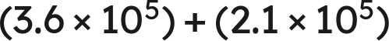 1 pt

Same power: add the coefficients.
b. 1 pt
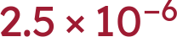
c. 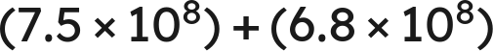 1 pt

 is the value; 14.3 is not less than 10, so it is not the answer.
d. 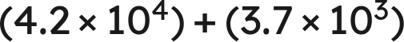 1 pt

.
Scoring: a 1 · b 1 · c 1 · d 1 = 4 points.

2. Multiply or divide. Write each answer in scientific notation.
a. 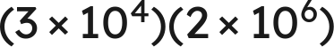 1 pt

b. 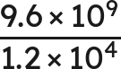 1 pt

c. 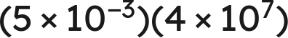 1 pt

 is not finished.
d. 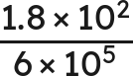 1 pt
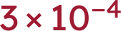
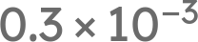 is not finished either.
Scoring: a 1 · b 1 · c 1 · d 1 = 4 points.

3. Which is the value of 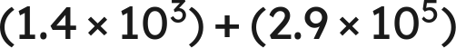 ? 1 pt
○ A. 
○ B. 
● C. 
○ D. 
C
Scoring: 1 point.

4. Select ALL of the expressions whose value is 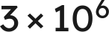. 1 pt
☒ A. 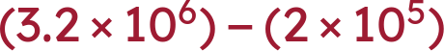
☐ B. 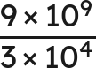
☒ C. 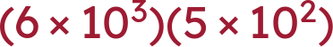
☒ D. 
☐ E. 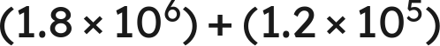
☒ F. 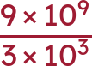
A, C, D and F
C gives , which is 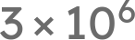 once it is finished. All four correct and nothing else for the point.
Scoring: 1 point.

5. Kendra writes . Name the two mistakes she made, and give the correct sum. 1 pt
She added the coefficients without first writing both numbers over the same power of ten, and she added the exponents. The correct sum is .
Both mistakes must be named for the point; one of the two is half the item. .
Scoring: 1 point.

6. A number is multiplied by 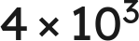 and the product is 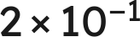. What was the number? Write your answer in scientific notation. 1 pt
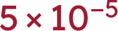
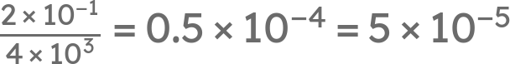. Working a product backwards across a sign change appears on no review and in no question bank; the point is for the finished form, so 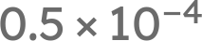 alone does not earn it.
Scoring: 1 point.

Part 2. Real-World Problems in Scientific Notation 4 points
If an earlier part is wrong, a later part still earns its point when the right operation is applied to your own earlier answer — but only if that work is on the page.
7. Solve. Write each answer in scientific notation. Do not round.
a. A rectangular plate measures 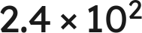 mm by 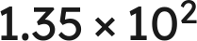 mm. Find its area. 1 pt
 square millimeters
Multiply the coefficients and add the exponents: 2.4 · 1.35 = 3.24, and .
b. A vehicle travels  km in 8 hours. Find its average speed. 1 pt
 km/h
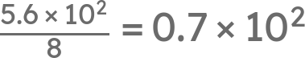, which is not finished: 0.7 is less than 1.
Scoring: a 1 · b 1 = 2 points.

8. Solve. Write each answer in scientific notation. Do not round.
a. Two lengths are measured:  mm and  mm. Find their sum. 1 pt
 mm
Match the powers first: , and 6.25 + 0.41 = 6.66.
b. Two masses are measured: 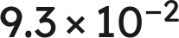 g and 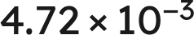 g. Find their difference. 1 pt
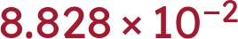 g
Match the powers first: , and 9.3 − 0.472 = 8.828.
Scoring: a 1 · b 1 = 2 points.

Part 3. The Order of Operations with Exponents and Radicals 13 points
If an earlier part is wrong, a later part still earns its point when the right operation is applied to your own earlier answer — but only if that work is on the page.
9. Evaluate each expression.
a.  1 pt
−3
The power first, then the product, then the subtraction.
b. 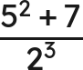 1 pt
4
32 over 8; the bar groups the whole numerator.
c. 36 ÷ 4 · 3 1 pt
27
One level, left to right: 9 · 3. Not 3.
d. 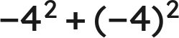 1 pt
0
−16 + 16. The parentheses decide what the exponent is attached to.
Scoring: a 1 · b 1 · c 1 · d 1 = 4 points.

10. Evaluate each expression.
a. 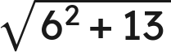 1 pt
7
Finish under the bar: 36 + 13 = 49.
b. 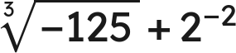 1 pt
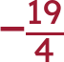
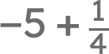.
c. 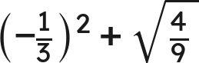 1 pt
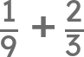.
Scoring: a 1 · b 1 · c 1 = 3 points.

11. A square patio of side 14 feet is sealed at 2.40 dollars a square foot, with a flat 85 dollars for delivery.
a. Write an expression for the total cost. 1 pt

The rate multiplies the area; the flat fee does not. An expression that charges 85 on every square foot does not earn the point.
b. Find the total cost. 1 pt
555.40 dollars
196(2.40) = 470.40, then + 85.
Scoring: a 1 · b 1 = 2 points.

12. Which is the value of 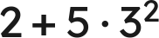 ? 1 pt
○ A. 32
● B. 47
○ C. 63
○ D. 289
B
Scoring: 1 point.

13. Select ALL of the expressions whose value is 6. 1 pt
☐ A. 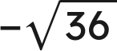
☒ B. 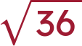
☐ C. 36 ÷ 3 · 2
☒ D. 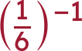
☒ E. 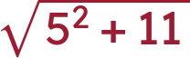
☒ F. 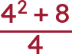
B, D, E and F
All four correct and nothing else for the point.
Scoring: 1 point.

14. Nadia writes . Explain why she is wrong, and give the correct value. 1 pt
The radical bar is a grouping symbol, so 25 + 144 is finished before the root is taken: 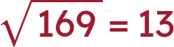. The root of a sum is not the sum of the roots.
The point needs the reason AND the value. '13' alone does not earn it, and neither does 'she added wrong'.
Scoring: 1 point.

15. A square tile has an area of 169 square inches. A second square tile has a side twice as long as the first. What is the area of the second tile? 1 pt
676 square inches
The side of the first is 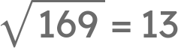, so the second has side 26 and area . Doubling a side and asking for the new area appears on no review and in no question bank; a student who doubles the area and writes 338 has not gone through the side.
Scoring: 1 point.

